SEMINAR SYLLABUS
for Foundation Field Seminar 2023-2024
at the University of Maryland, Baltimore School of Social Work

PURPOSE

Field seminar offers students and instructors opportunity to bridge classroom content with practice, develop skills and technique for intervention, explore field experiences, develop professional identity and competence, and reflect on the practice implications of ethical situations and personal biases through instructor and peer-guided discussion. Field seminar uses a small-group, cohort model which allows for the opportunity to intensify critical self-reflection and interrogation of personal beliefs to optimize students’ ability to adopt a culturally sensitive and humble approach to practice. Ultimately, participants in the field seminar will focus on the development of an anti-oppressive approach to practice, including empowerment of constituents to guide and control their own lives towards progressive social change. This effort will occur through discussion of field experiences – what happens in field between seminars – and best practices for skill development under an anti-oppression lens.

GRADING

Students will receive a passing grade based on the following two components:
- Attendance in all seminar sessions for their entirety. Attendance includes arriving in the session on time, being on-screen and leaving when the session concludes.
- Active participation in seminar sessions. Sessions are meant to be highly interactive and your participation is important.

POLICIES
- ATTENDANCE and DURATION: Field seminars are held online every month for 90 minutes for both fall and spring semesters. They are mandatory and count towards accumulated time in field. Seminar times will occur at the same day/time each month, as designated by the seminar instructor. Seminar times should not interfere with class schedules, but may occur on, or outside of a regular field day. Attendance and participation are required – students may NOT schedule a class during seminar time in either the fall or spring semesters. Students are responsible for planning seminar into their schedules, notifying their field instructors of seminar times in advance (where applicable), and appropriately planning to ensure attendance.

- ABSENCES: Foundation Field Seminar is a required part of the field education course, and attendance and participation are mandatory. As with your agency placement, you must be present to participate and receive credit. Partial credit for lateness or early departure from seminar may be applied at the discretion of seminar instructors. Students may miss a maximum of one (1) seminar session for any reason. If a student misses more than one (1) seminar session for any reason, the student is at risk for failing field. Students are also expected to communicate with their instructors about any anticipated absence in advance of a scheduled seminar session. If a student is unable to attend their assigned seminar, they must inform their liaison seminar instructor immediately to find a resolution, which may include completion of a written reflection assignment given by the liaison seminar instructor that has relevance to the discussion during the missed seminar.
.
- RECORDING: No audio or video recording of sessions is permitted. Sessions are meant to be highly interactive and student-driven with minimal lecture. To protect the privacy of your colleagues, it is essential that no one records. This includes the use of outside recording devices that are independent of the zoom software (e.g. recording with a smartphone).

- CAMERA USE: In the spirit of being fully present and equally engaged, students are strongly encouraged to show themselves on camera during the entire seminar session. Extenuating circumstances that preclude safe or comfortable camera use must be approved. Students with cameras off for an extended period without an instructor approved explanation may be marked absent for the seminar session.

- ZOOM ETIQUETTE: The field seminar is an online, synchronous course. Please note the following:
  - Please ensure you have a sufficient internet connection for each session -- use WiFi or have a strong signal if you are using a mobile network.
  - Please have adequate light on your face. Seminar sessions are part of learning direct practice, so we need evidence of your ability to express active listening skills (smiles, frowns, nods, etc.) Therefore, we need to see your face clearly enough to see your facial expressions. Please avoid sitting with your back to a sun-filled window or bright lamp; direct backlighting can make it challenging to see your face.
  - Please wear clothes as if you were in a public professional setting. We are not asking for business attire, but something you would consider appropriate for meeting with colleagues (including a supervisor) at your field placement or a place of employment.
  - If you are unable to be in a space alone, please wear headphones to protect the privacy of your colleagues. (Even if you are alone, headphones seem to work better for most of us to avoid echoes and feedback.) If you do not have headphones and cannot be in a private space, the UMSSW Office of Field Education can assist you in getting them.
  - If possible, please be in a room with minimal distractions behind you and minimal noise when you are not muted. (This is aspirational. We understand that it is not possible to have privacy 100% of the time for most of us at home or at field. All we ask is that you keep in mind that we are attempting to create a professional setting. In this spirit, we’d like your help by minimizing the distractions that are within your control.)
  - Please mute yourself at all times when not speaking. (Pro-tip: On a computer, pressing and holding down the spacebar will temporarily mute or unmute you.)
  - Please minimize all distractions during seminar. Eating food, smoking or vaping, using your phone, or having conversations with others, even while muted, are distracting to your colleagues, and especially to those speaking. We seek full, equal and respectful engagement. If you are texting or speaking with someone standing out of frame, you are not present with your colleagues. If you absolutely cannot wait for a break to engage in one of these activities, simply turn off your camera momentarily and turn it back on ASAP.

Foundation Field Seminar Objectives

During the foundation field placement, foundation students will participate in monthly, online, facilitated, small group seminars. In these seminars, students will:

- Become oriented to the principles and practice of social work.
- Practice critical self-reflection to improve self-awareness, and awareness of the impact of self on developing professional identity.
- Discuss issues of oppression, privilege and cultural humility, and integrate the practice of critical self-reflection within an anti-oppression, culturally humble framework.
- Bridge material learned in class with the practical application of that material and other practices in field.
- Discuss experiences and troubleshoot issues in field.

Prerequisite Required Readings
The following readings are required and must be read PRIOR to your first seminar and will be provided to you by your liaison seminar instructor.

Christopher, G. C. (2017). Truth, racial healing and transformation: Creating a public sentiment. National Civic Review, A Journal of the National Civic League. Wiley Online Library (wileyonlinelibrary.com), Fall 2017, 12-19.

Stubbs, V., (2019) The 6 Pillars of a Brave Space. UMSSW Teacher Support Program. Retrieved: https://www.teachingsupportprogram.com/the-6-pillars-of-a-brave-space

Shaia, W. (2019). SHARP: A framework for addressing the contexts of poverty and oppression during service provision in the United States. Journal of Social Work Values and Ethics, 16(1), 16-26.

Recommended Reading

Burke, T. and Brown, B. (2021) You are your best thing: vulnerability, shame resilience and the black experience. New York: Random House.

Coates, T. (2015) Between the world and me. New York: Spiegel and Grau.

Kendi, I.X. (2019) How to be an antiracist. New York: One World.

Kendi, I. X. (2017) Stamped from the beginning: the definitive history of racist ideas in America. New York: Bold Type Books.

Oluo, I. (2019) So you want to talk about race. New York: Seal Press.

Saad, L. (2020) Me and white supremacy. Illinois: Sourcebooks.

Saslow, E. (2018) Rising out of hatred: the awakening of a former white nationalist. New York: Doubleday.

Seminar Sessions

Session 1  August  Orientation - Introduction of Field Seminar  Preparation for next seminar: Complete “Charlie” avatar-based simulation. Upload outcomes to EFN | - Team building activity  - Introduce roles of seminar instructor & field instructor  - Review seminar objectives and syllabus  - Review and discuss models and frameworks supporting seminar (from required readings)  - Develop seminar group norms (Touchstones)  - Explore expectations of and questions about field and seminar  - Introduce avatar simulation: “Charlie”

Fall Semester –
Self-Awareness/Knowledge and Beginning Concepts of Practice

Session 2  September  Introduction of First Seminar and Engagement Part 1: Getting Started  Preparation for next seminar: Study the models that guide our seminar and discuss them with your field instructor (They should have a copy). Consider how they may apply to your agency and clients. What does your field instructor think? Be prepared to discuss your thoughts and feelings about our seminar models. | - Review Group Norms  - What to expect in field:  - Use of supervision – see Supervision Worksheet (attached)  - Safety  - Learning Agreement  - Diversity Spotlight:  - Review the social justice question in process recordings and monthly reports  - Identity Awareness  - Engagement, Part 1: Review Charlie simulation  - IF there is time: What do you know about social work and your agency, and how does that influence your role (Assumptions, history, transparency, power)?
Session 3  October  Ethics, Engagement Part 2 and Introduction to Student-led case discussions  Preparation for next seminar: SHARP is a “how-to” model for practice in our seminar. How does it apply to what you are learning about your agency? Review a copy of your agency’s psychosocial history form through a SHARP lens and discuss with your field instructor. Come prepared to share this discussion in the next seminar. | - Review assignment for student-led case discussion  - Discuss responses to seminar models:  - Discuss what you think about Rx Racial Healing, The 6 Pillars, and SHARP – are they applicable to your agency/clients? How did your field instructor respond? How would you apply them to working with your clients?  - Diversity Spotlight:  - Review social justice reflections in process recordings and monthly reports  - Personal identity in context: impact and intersectionality  - Engagement, Part 2: What must you consider regarding ethics, boundaries, and power dynamics within your agency and between agency providers (including you) and clients.
Session 4  November  Supervision and Documentation; Identity in Context  Preparation for next seminar: Review the Supervision Worksheet and compare to the agendas you have prepared for supervision. | - Student-led case discussion(s)  - Discuss findings of agency psychosocial histories through the SHARP lens  - How do power dynamics show up at your agency? How do they show up for you in field?  - Diversity Spotlight:  - Review social justice reflections in process recordings and monthly reports  - Intersectionality in context – impact and interplay with agency people and culture  - Supervision styles and use of supervision – review Supervision Worksheet  - Documentation and the importance of language  - Check in:  - Intervention and treatment planning  - Models and Evidence-Based Practices – how to use them?  - Standardized treatment protocols – pros and cons
Session 5  December  Self-care, Professional Responsibility, Spirituality  Preparation for next seminar: Reflect on your skills and perceptions from the fall – how have they evolved? | - Student-led case discussion(s)  - Discuss how the supervision worksheet applies to working with your field instructor  - Diversity Spotlight:  - Review social justice reflections in process recordings and monthly reports  - Spiritual diversity  - Client coverage  - Self-Care  - Reflect on the fall semester

Spring Semester –
Integration of Self with Professional Identity and Reinforcement of Introductory Practice Concepts

Session 6  January  Re-engagement, Reflection, Progress and Crisis  Preparation for next seminar: Consider what you learned in the fall in classes and in field – how are you shaping your professional identity as a social worker? | - Student-led case discussion(s)  - Re-engagement/Re-centering  - Assessment of progress – celebrate success!  - Diversity Spotlight:  - Review social justice reflections in process recordings and monthly reports  - Evolution of perspectives – what does it mean to be an anti-oppressive social worker?  - Reflect on identity and use of self  - Internalized oppression and trauma triggers
Session 7  February  Introducing termination, Ethics, Identity integration  Preparation for next seminar:  Pay close attention to the DEI reflection question in your process recordings – are you taking care with your response? Are you applying anti-oppressive thought to your practice? Discuss in supervision and be prepared to share in our next seminar. | - Student-led case discussion(s)  - Discuss ways in which practice models like SHARP are, or are not applicable to all stakeholders in field – why or why not? How have you used them?  - Diversity Spotlight:  - Review social justice reflections in process recordings and monthly reports  - Integration of personal/professional identities  - Agency through structural oppression lens  - Termination How-to’s
Session 8  March  Transition planning, Identity integration, Reconciliation | - Student-led case discussion(s)  - Review process recording DEI reflections and field instructor input. Are you “doing the Work?”  - Diversity Spotlight:  - Review social justice reflections in process recordings and monthly reports  - Identity integration with social work profession: Professional goodness of fit?  - Warm hand-off:  - Termination sessions with clients  - Documentation review  - SHARP next steps for your clients? A sustainability lens

Session 9  April  Termination and Reflection, Impact Evaluation, Furthering Cultural Humility | - Termination with all stakeholders  - Diversity Spotlight:  - Review social justice reflections in process recordings and monthly reports  - Furthering “the work” – continual anti-oppressive practice and/or use of SHARP  - Reflect on spring semester  - Reflect on year  - Impact evaluation

Clinical Case Presentation Outline

The following outline is intended to offer a guideline for the depth and quality of information you might share in a case presentation or discussion. For the purposes of seminar and the case discussion assignment, please select criteria most applicable to the client issue you wish to discuss with your seminar colleagues. Please do not prepare a presentation inclusive of every criteria – your selection of what information to share for discussion is as much a part of this assignment as the discussion itself! Practitioners also rarely have more than 10 minutes to present a case to colleagues due to high caseloads and inadequate time for the work.

This is not intended to be a formal presentation (ie. NO PowerPoints!), but an opportunity to discuss a challenge or highlight you wish to bring to your seminar group. Individual case discussions will mirror real practice conditions so should last no more than 15 minutes of seminar time: 10 minutes to present information and 5 minutes for Q&A, at your seminar instructor’s discretion. You should be familiar with the agencies where your colleagues are placed by now, so focus on the client information without a full agency description.

- Identifying Data
- Client demographics (age, gender, sexual orientation, marital status, children, living situation, employment/education, race/ethnicity)
- Services client receives at your agency.

- Past and present psychiatric history
- Has the client received treatment/services previously? What was the outcome?

- Family History
- Client/Family Strengths
- Client/Family Challenges
- Assessment of supports – family and/or friendships

- Cultural Diversity Issues
- What cultural identities has your client shared with you?
- What, if any, are the implications of these identity(ies) on your client’s situation?

- Presenting Problem
- Why did the client come to treatment/services?
- How has the problem developed over time?

- Current Health Concerns and Medications
- Does your client have any health issues?
- Is your client currently taking any medications?
- What, if any, impact do these have on your client’s situation and need for services?

- Risk Factors
- Is your client currently experiencing, or have a history of any of the following:
  - Suicide,
  - Violence,
  - Substance use,
  - Domestic violence,
  - Other risk factors?

- Substance use/abuse – detail
- If your client is currently, or has a history of using or abusing substances, please describe:
  - Substances used
  - Amount and frequency of use
  - Circumstances of use

- Diagnostic Impressions
- Given what you have learned about this client, do you believe there may be a diagnosable condition?
- Consult the DSM

- Treatment Goals & Interventions Used
- Please share treatment plan and approach to treatment

- Ethical Issues
- What are the ethical implications to be considered in working with this client?

- Counter transference
- How do you feel about this client and how does it affect your work?

- Feedback
- Why have you selected this case to present?
- What difficulties or challenges are you having with this client?
- What successes have you had while working with this client?
- What questions do you have for the group?

Supervision Worksheet

Please use this template to prepare for weekly supervision meetings with your field instructor. It may not be necessary or applicable to include something under every prompt, but you and your field instructor should agree on which prompts in this worksheet must be used, and what, if anything, should also be included. Using this format will ensure consistency and reliability among supervision times for you and your field instructor.

Student: _____________________________________

Field Instructor: _____________________________________

Date: ______________________________ Time: __________________________

- Self-Care: How will you take care of yourself this week? Consider focusing on one area of your life such as your physical, mental, spiritual, financial, etc. needs.

- Benchmarks: What is due this week and what is your plan for getting it done? (Ex. Case Notes, Process Recordings, Monthly Reports, etc.)

Item | Due Date | Given to Supervisor | Returned to Student | Submitted to Liaison | Discussed in Supervision

- SHARP Framework: How did you explore one or more of the aspects of the framework with yourself, caregiver/family, and/or community stakeholder?

S – Structural Oppression

H – Historical Context

A – Analysis of Role

R – Reciprocity and Mutuality

P – Power

- What are some challenges you’re experiencing at the moment?

- What are some ways to resolve these challenges?

- What did you accomplish this week so far?

- Take a moment to reflect on something, someone, or an experience you are grateful for this week.

Field Instructor Only
Did I ….

- Review the process recording and monthly report with the student
- Review the mid-semester evaluation with the student
- Review the final semester evaluation with the student
- Review key projects with the student
- Review case information (case notes, case milestones, comprehensive family assessment, service activities and other documentation)

Cultural Humility Reflection Questions in Field Assignments

Process Recording:

Social workers’ awareness of privileges and power differentials with our clients is critical to a culturally humble practice. How might privilege and power dynamics arise in this interaction with you and this client? Did they come up? How? What did you do?

Macro Process Recording:

Power: Identify individuals present and their role/title. Provide commentary on and reactions to dynamics of power and influence (who has it, how is it displayed). Comment on issues of diversity, inclusion and oppression related to this event.

Monthly Report:

Reflect on experiences in your internship that relate to diversity, inclusion, oppression and/or privilege.

SHARP Framework

S – Structural Oppression – What are the issues in the person’s physical and social environment that impact the person and their ability to be successful?

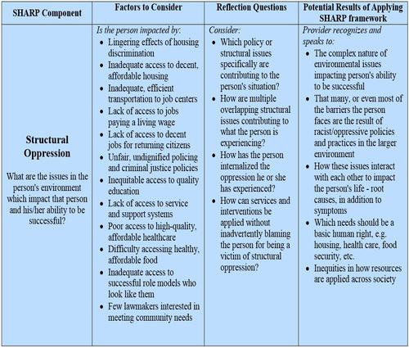

H – Historical Context – What historical issues impacting the person’s environment/community might be relevant to the issues the person is experiencing now? How has this history contributed to the situation the person is in now?

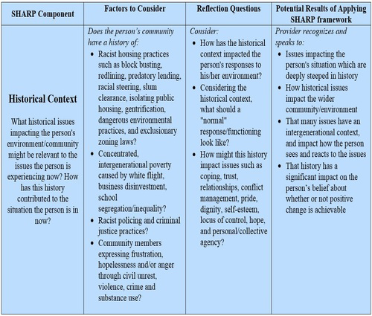

A – Analysis of Role – What will be the provider’s role in this service relationship: maintiner or disrupter of the staus quo? There is no neutral space.

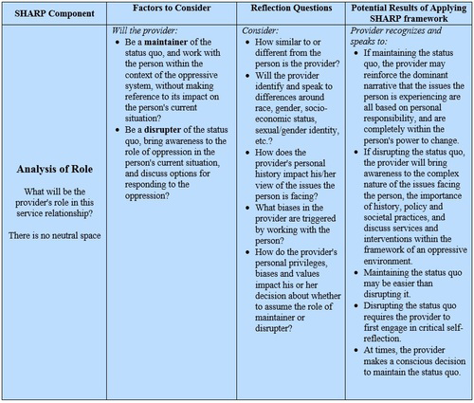

R – Reciprocity and Mutuality – What strengths and gifts can the person share with the provider and with their community?

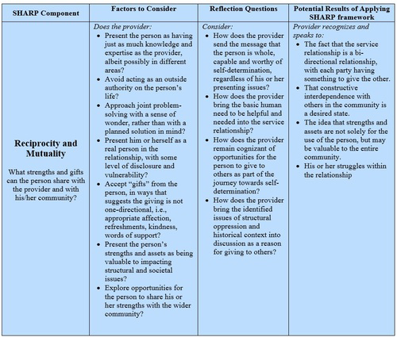

P – Power – What can the person do, alone and/or with others, to change the impact of historical and structural oppression?

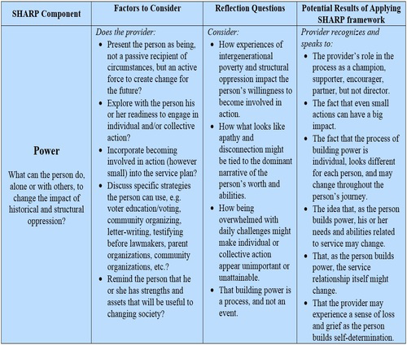

This syllabus may not be shared, reproduced or copied without explicit permission from the Office of Field Education at UMSSW.
This list is a sampling and not exhaustive by any means. If you are aware of other books or readings that support anti-oppressive social work practice, please share them with your seminar instructor and the Office of Field Education.
Based on “How to give a social work clinical case presentation,” by Sharon Martin, LCSW as adapted by Caron Cox-Branch, LCSW-C
From “Supervision Worksheet” provided by LaShonda Godwin, LCSW-C
5 Shaia, W. (2019). SHARP: A framework for addressing the contexts of poverty and oppression during service provision in the United States. Journal of Social Work Values and Ethics, 16(1), 16-26.

